Native American Crystal Healing Course
With renowned Shaman, Blue Eagle
Huron-Wendake Reservation, Quebec, Canada
April 22-27, 2020

“The first crystal you work with is yourself” - Blue Eagle

Invitation ~

We are delighted to announce this rare and precious opportunity to study Crystal Healing with Blue Eagle, an internationally recognized Native American shaman, teacher and artist. Upon request, he is offering this exceptional 6-day comprehensive course in English for one time to a select group of participants.

Previously taught only in French as 3 weekend workshops, this unique offering will be a powerful transmission of crystal healing in an immersive and intimate environment, from a shaman whose mastery in relationship to these most evolved representatives of the mineral kingdom is but one of his many areas of accumulated knowledge.

Blue Eagle ~

Blue Eagle’s natural affinity with crystals first appeared at the age of four, and after years of studying and cultivating Native American healing traditions with many native elders, his work in crystals, and their use in healing and ceremony, is internationally recognized. During his 30-year teaching history, he has taught in France, Belgium, Switzerland, Austria, Germany, Portugal, Mongolia and Japan. Learn more about Blue Eagle at https://aiglebleu.net/en/

About the course~

First Nations teachings have always been passed down through word of mouth, until recently. Blue Eagle has been given permission from his elders to commit these teachings to writing so as to correct some “new age” misinformation, in particular what is referred to as the “power of the crystal”. Working with crystals requires a lot of spiritual energy and focus. Crystals do not decide what they are amplifying - they are not doing the work, they are used to amplify your energy.

Of course, there are many things that crystals naturally do and in order to uncover some of the mysteries of this age-old science, which can be of great benefit to many people, Blue Eagle will present traditional philosophies, practices and methods in order for us to better understand, experience and work with energy and crystals.

There are two different approaches, or paths, to this kind of work that Blue Eagle works with and teaches. We will get both, including:

- that of the shamanic work, which many First Nations and particularly the Apache use, having a shamanic relationship to a specific stone, dealing with the spirit of the stone,
- and that of the Mound Builders – the Cherokee, Navaho, Hopi and Maya who had ceremonial structures and a more organized spirituality. They played with the science of crystals, of organized matter – amplifying, organizing and focusing energy.

During the 6-day program of oral teachings and of hands on experience, essential for working with crystals, we will be given:

- Traditional philosophies on the main principles guiding the use of crystals for therapeutic purposes.

- Traditional practices of purification and harmonization, including meditation exercises, to help clarify the mind and body and increase vital energy in order to feel the energies emitted by the crystals.

- Teachings on how to directly use the healing quartz crystal for therapeutic purposes.

- Personal feedback of experiences and progression so as to consolidate and intensify the work.

- An introduction to various rituals and practices requiring more advanced skills.

- Transmissions of more advanced techniques, in particular regarding the shamanistic use of crystals.

Additionally, we will learn:

- To uncover personal ways of understanding and relating with crystals.

- Sacred movements from the Cherokee tradition which will be practiced daily to cultivate a relationship with and draw in the energies of all the directions and to possess the spiritual presence required to work with energies.

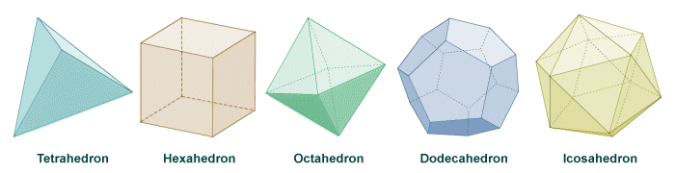
- Beginning levels and proper use of Platonic Solids. The sacred geometry of the 5 geometrical shapes, also relating to the 5 elements, can be used to manifest various aspects of reality. In the distant past, knowledge of platonic solids were sacred and hidden. We will work with these 5 shapes as a set of crystals.

At a glance, the workshop will include some of the following:

- Purification and Care of Crystals
- Stones and their Properties
- Different Ways of Working with Crystals
- Practical Exercises
- The Fundamental Laws of Healing and the Programming of Crystals
- Colors and their Properties
- How to Prepare Essences and the Body's Electromagnetic Fields
- Therapeutic Touch
- Treating with quartz crystals

In addition to this 6 full-day program, Blue Eagle has generously offered 2 or 3 Evening Offerings which could include music, healing ceremonies, crystal healings, rituals...

Where ~
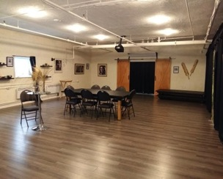
Blue Eagle’s healing center and office, Invocation, Ltd, is located in Wendake, Quebec on the Huron- Wendat Reservation - just 20 minutes from Quebec City in the French speaking region of Canada. The self-governing territory honors it’s rich heritage with a thriving artisanal community nestled in current modern day living. We will meet in the Discovery Zone space at www.invocation.ca/en

More information about the area, accommodations, and Blue Eagle and his work can be found on the sites below. The First Nations Hotel-Museum is a 4 star boutique hotel and is the closest to the course being a 5 minute drive.

www.quebecregion.com/en/quebec-city-and-area/wendake
http://tourismewendake.ca/hotel-musee-premieres-nations/en/
http://tourismewendake.ca/en/
https://indigenoustourism.ca/en/things-to-do/tourisme-wendake/
https://aiglebleu.net/en/

Requirements ~

A spiritual base is recommended so that you can hold the energy of the work. Good physical health that will allow you to practice the gentle movements of the sacred dance.

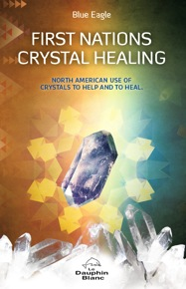
Particulars ~

•Cost - $900 Canadian Funds (approximately $674 US)
- 6 full days
- 2 or 3 evening offerings - optional for participants
- Includes First Nations Crystal Healing e-book by Blue Eagle (English Translation)
- Does not include accommodations, meals, or travel

•Course is limited to 20 participants.
•Course will be given in English.

April 21, 2020 – Arrival day (Quebec City Airport is nearby)
April 22 – 27 – Course (Auspiciously timed to begin on the
New Moon, added bonus Earth Day)
April 28 – Departure day

Payment policy – 50% down payment of $450 Canadian via PayPal to hold your place. (Payment is in Canadian Dollars - PayPal account will convert from US Dollars. $900 Canadian Dollars is approximately $674.14 US Dollars today.)

Final payment of $450 Canadian is due February 20, 60 days before the workshop to secure your spot. Thank you for your consideration. We know we will have a waiting list and will need time to contact others should you need to cancel.

Cancellation Policy – Your deposit will be refunded in full via PayPal if you cancel prior to February 20, 2020. Please note CND to USD rate may vary from when you made the deposit. PayPal fees apply. Consideration will be given to illness or family issues after 60 days.

For registration inquiries, please contact Blue Eagle at blueeagle@invocation.ca

